

G2 EE

Scrap and Return to Vendor

QAD EE Training Document

Scrap and Return to Vendor

Table of Contents
Objective 3
Reason Codes Maintenance 36.2.17 3
RTV 3
*Supplier Schedule Return Maint 5.5.5.19 3
*Supplier Schedule Return Doc. 5.5.5.20 6
*Purchase Order Returns by Pack 5.13.12.16 7
Checking transaction details 3.21.2 7
Scrap 8
Scrap for plants using AS 8
*Inventory Scrap By Pack 3.17.12 8
Scrap for plants NOT using AS 9
*Scrap Maintenance 3.14.1 9
Item Scrap Report 3.6.21 13
*Scrap Browse 3.14.3 14
Inventory Scrap Trans Browse 3.6.23 14

Objective
Purpose of this document is to explain the Scrap and RTV processes in QAD

Reason Codes Maintenance 36.2.17
Reason codes are required for RTV and Scrap transactions.
Enter the reason type (Scrap or RTV) and reason code. Click Next and enter a description.
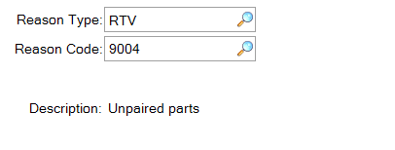
You can view the available codes (including those newly created) in Reason Codes Browse 36.2.18 or Reason Codes Report 36.2.19.

RTV
Return to Vendor transactions are used to process returns of goods to suppliers. This will create a financial transaction so it is important that the supplier is aware of this and has agreed to accept the related costs. For parts damaged by Adient a scrap booking should be used – see separate scrap section in this document.
It is very important when carrying out a RTV booking that the correct PO is used. As far as possible the PO number should be used on which the parts were received. Make sure you have the current data – creating new transactions using old POs will cause problems for the finance team and you will have to correct them later.
This transaction also affects the cumulative quantities received from the supplier. This can be critical in terms of orders – make sure your logistics department is aware that this transaction has been made.

*Supplier Schedule Return Maint 5.5.5.19
This program is used for Return to Vendor transactions performed by the quality department.
Enter the PO number and click Next.
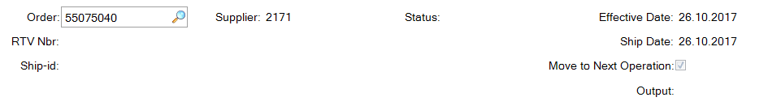
Then enter the IRIS SMRR number. This is available once the SMRR has been created in the IRIS system.
Do not include IRIS- as this number is limited to 20 characters SMRR-10001234. Ship-ID entry is not required.
This is key because the data booked in QAD will be used to create a debit note for the supplier and this number will appear as a reference. If this is not both present and identical to the IRIS number then the supplier will not be able to match the invoice, making manual work necessary at the supplier, in Bratislava and in your facility.
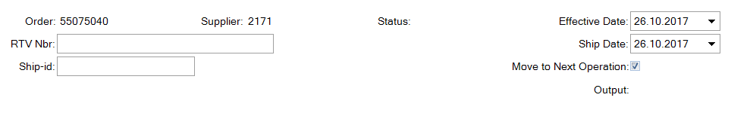
Click Next and then Back in the comments window. You can now enter the part number.
In the upper half of the window you are shown all part numbers and quantities received on the PO. It is not possible to return larger quantities than you have received. This avoids the supplier rejecting the request. If the PO number has changed recently, parts must be returned based on the PO that they were received on.
Make sure the location from which the parts will be booked is correct.
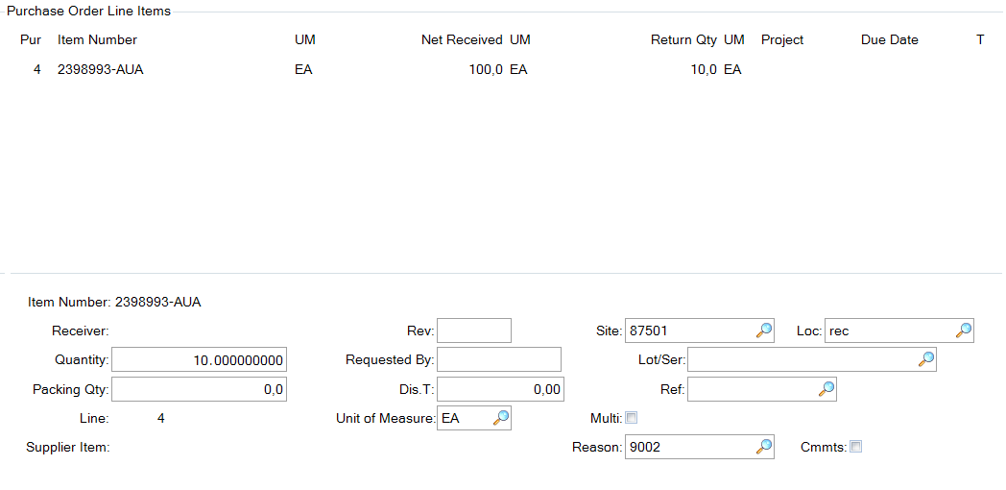
Total received and returned quantities
Select a code in the Reason code window (by clicking on the magnifying glass or entering manually)
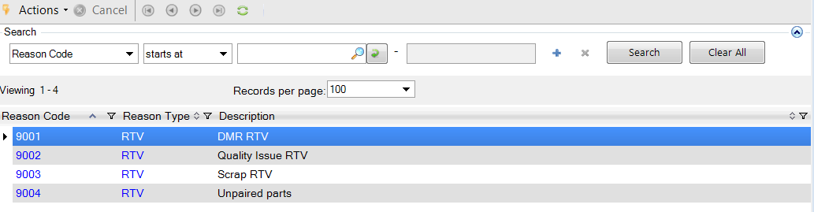
Click Next and you will be asked if you want to see the quantities. Click Yes.
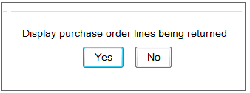
An overview will then be shown of the quantities to be returned. Make sure this matches what you need.
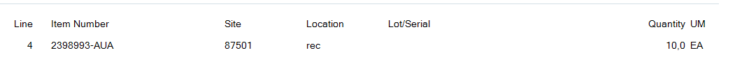
Click next and confirm everything is correct. Booking complete.
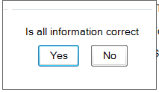

*Supplier Schedule Return Doc. 5.5.5.20
This program prints a document to accompany the parts being returned to the supplier.
Enter the relevant data at the top:
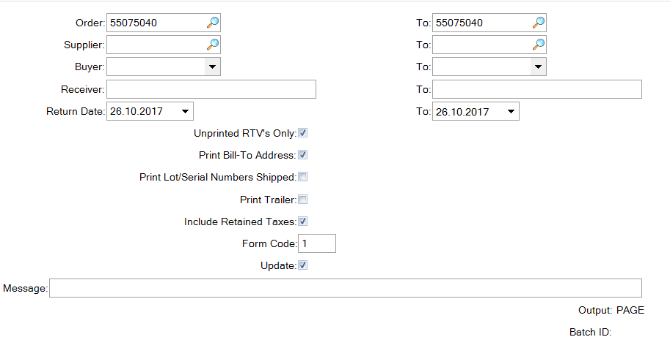
A report will be created showing the data from the RTV booking to accompany the shipment.
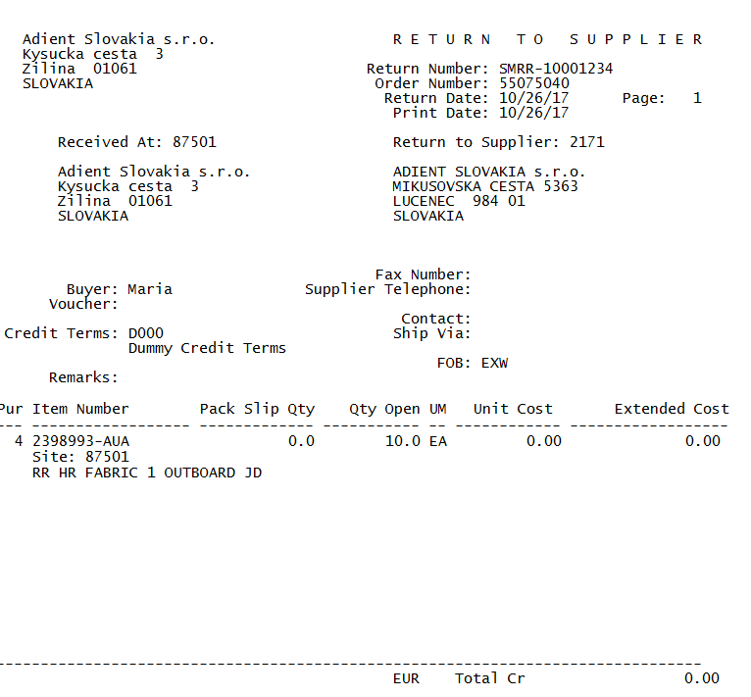

*Purchase Order Returns by Pack 5.13.12.16
This menu exists for returns of serialized inventory. Should this be required the functionality is very similar to the standard RTV process above, simply with the serial data must be entered.

Checking transaction details 3.21.2
Use the Transactions by Item Browse to view the details of the RTV transaction.
Select details in the filter to see your transactions.
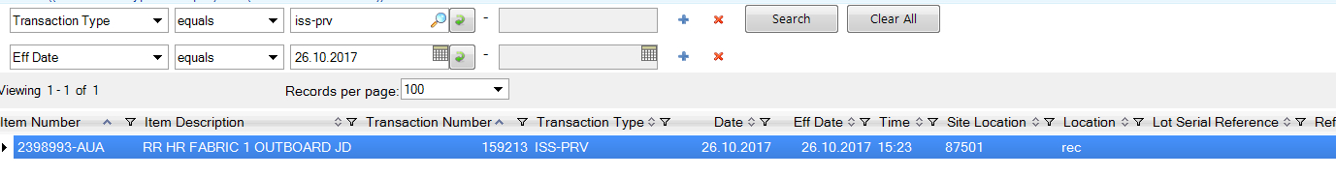

Scrap
Scrap transactions are used to process goods which are to be paid by Adient. This will create a financial transaction so it is important that you are sure this issue was not caused by the supplier – if it was then an RTV transaction should be used to return the parts to the supplier and charge them for the defective parts.
This menu is only to be used for scrap bookings (scrap from the Adient production line or similar), other bookings where Adient is responsible for the cost (training parts, testing etc.) are to be booked under 3.7 Issue Unplanned – see separate instruction.
Transaction is now called ISS-SCRP, in old V9 it was called ISS-SC.
Due to inventory serialization in AS there is a difference between the programs to be used for scrap transactions in plants with and without AS.

Scrap for plants using AS

*Inventory Scrap By Pack 3.17.12
Despite the name, this program is to be used for all scrap transactions in plants using warehouse management system AS.
This program will first request a serial ID. If you are scrapping a serialized container or parts within a serialized container then serial ID should be entered here. This will typically not be the case. Skip this step by clicking Next.
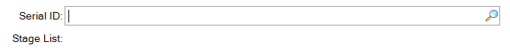
Enter the part number as required and click next.
Then enter the data as required.
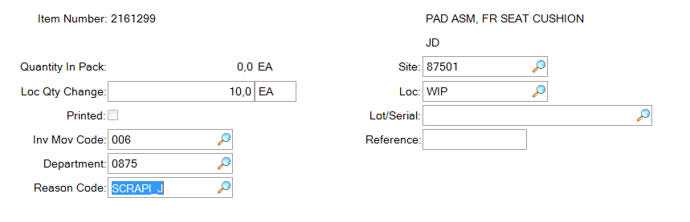
No entry typically required on the next screen. Click next and confirm that all data is correct.
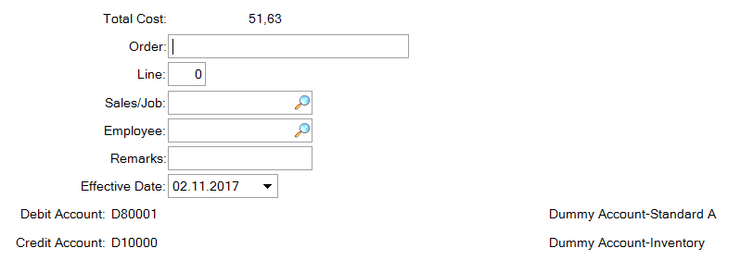
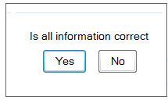

Scrap for plants NOT using AS

*Scrap Maintenance 3.14.1
This menu is used for inventory scrap transactions in plants not employing AS.
Enter the item number and click next. Then enter the quantity, Inventory Movement Code (006 for Scrap) and the appropriate department. Make sure the location shown is the one parts should be booked from, if not correct the location. Use the magnifying glass to see the options available to you. Click Next.
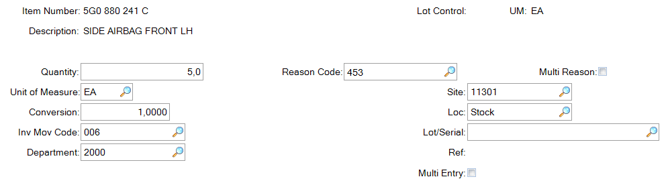
If required you can enter remarks in the next section.
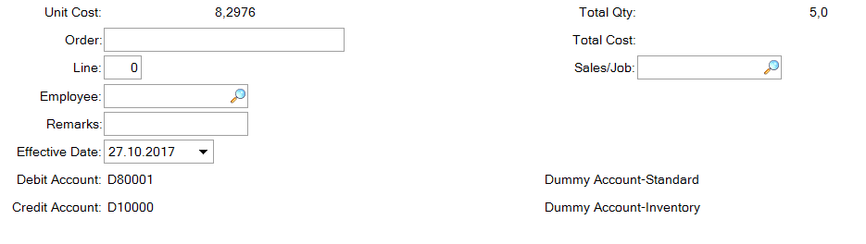
To continue click next. To confirm the booking click Yes.
Booking complete.
There are two further options available:
Multiple Reason Codes:
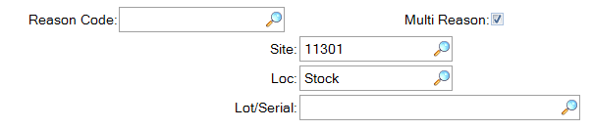

A separate window will open when you click next and the quantities per reason code must be entered. These must match, in total, the total quantity initially entered for the whole booking.
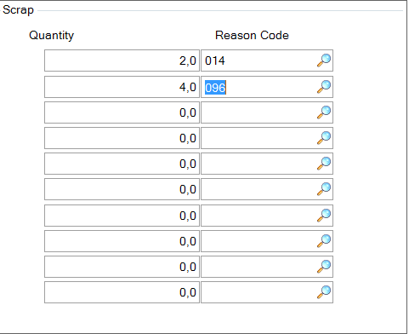

There is also the option of making multiple entries at one time This can be used to book from different locations if the complete quantity is not available on one location.
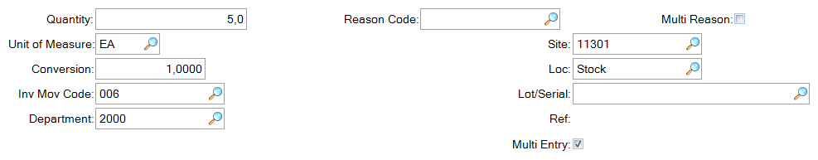

By selecting this box parts can be booked from more than one location or with more than one Reason Code. Enter the data as required. Enter at the bottom of the screen and the data will appear at the top.
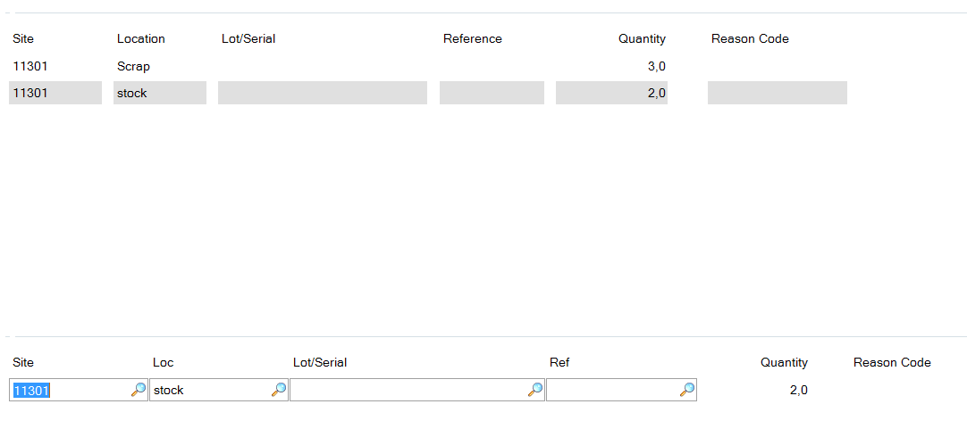
Click back when all data has been entered and you will return to the previous screen.

You will be asked if you want the data to be displayed, click yes
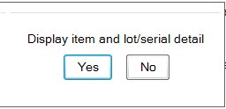
An overview will be shown
Click next and you will be asked if all data is correct. Click yes for the booking to be completed.

Item Scrap Report 3.6.21
This report can be used in both AS and non-AS facilities to view Scrap transactions.
Enter any parameters as required. Also see the sort options - choose the one most suited to the data you require.

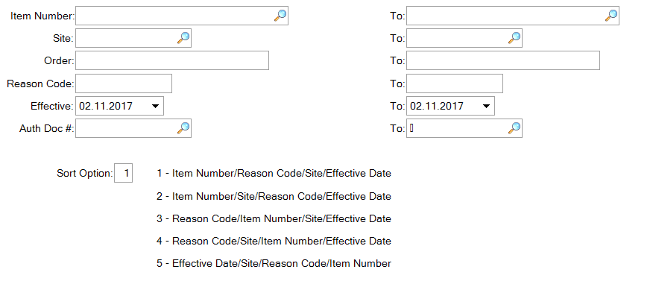

A report will open showing the requested data
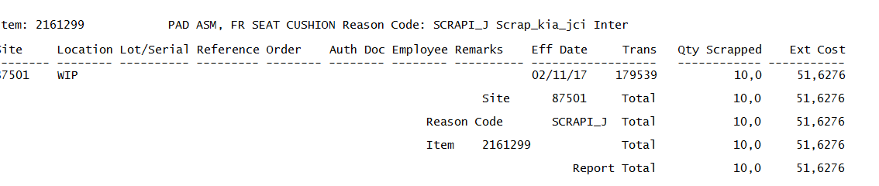
To export to Excel:
By entering an output name when creating the report it will then be available in the plant’s home directory to be transferred using the local file transfer tool (typically WIN SCP) and then opened in Excel.

*Scrap Browse 3.14.3
This browse can be used to view Scrap transactions
Enter criteria as required and view transactions
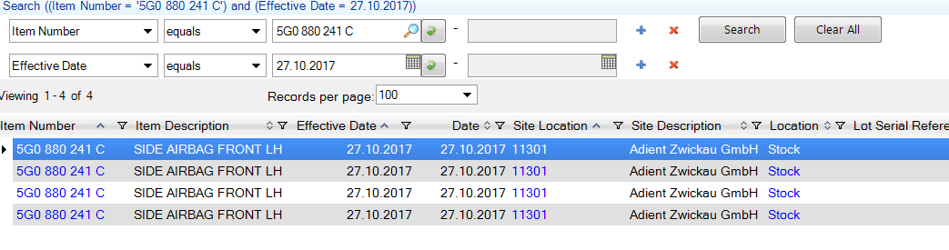
Scroll right for more data

Inventory Scrap Trans Browse 3.6.23
This browse is also available to view Scrap transactions

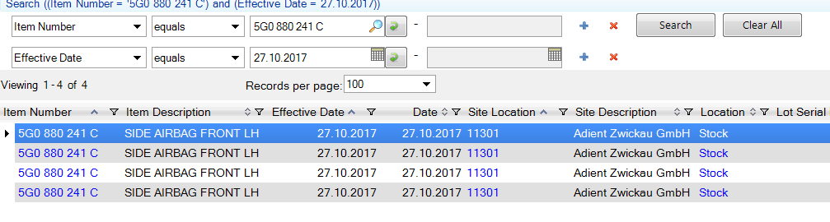
Scroll right for more data

